Your Company Letterhead

XX / XX / 2023

E Stream Software Sdn Bhd (200301008596/611016-M)
No 1, Jalan Setia Dagang AK U13/AK,
Setia Alam, 40170 Shah Alam, Selangor, Malaysia.

Tel : +603-78901300

To Whom It May Concern,

RE: RESET PASSWORD

Please reset password for administrator user for XXX Sdn Bhd. The challenge code is XXXX.

By requesting to reset administrator user password, we acknowledge that the request is for legitimate purposes from XXX Sdn Bhd. eStream Software Sdn Bhd will bare no responsibility or liability in the event of misuse resulting from the release of the administrator user password.

Yours faithfully,
XXX Sdn Bhd.

Chop & Sign here

- - - - - - - - - - - - - - - - - - -
Mr./ Ms. XXX

Step 1 :
Enter “ADMIN” in the User field and leave the Password field blank, then click Log on.
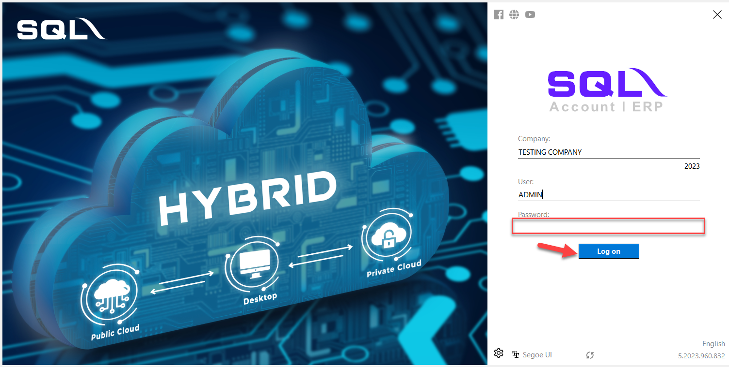

Step 2:
You shall see a prompt mentioning “Invalid user name or password”, just click OK.
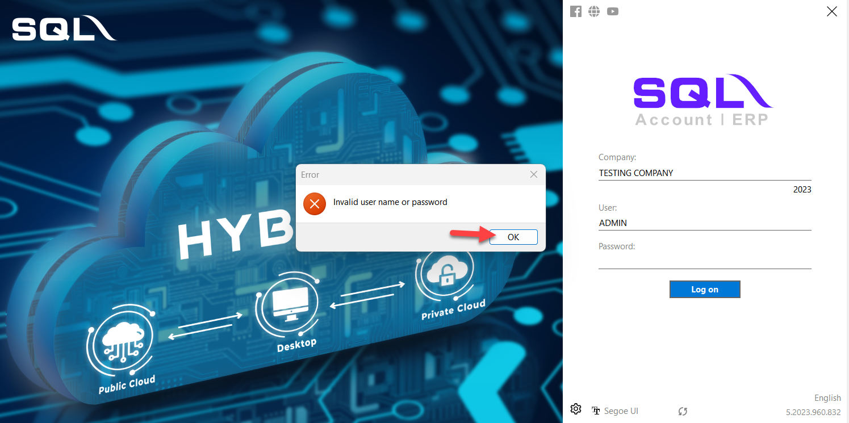

Step 3:
Click on the password field again and click the Reverse icon
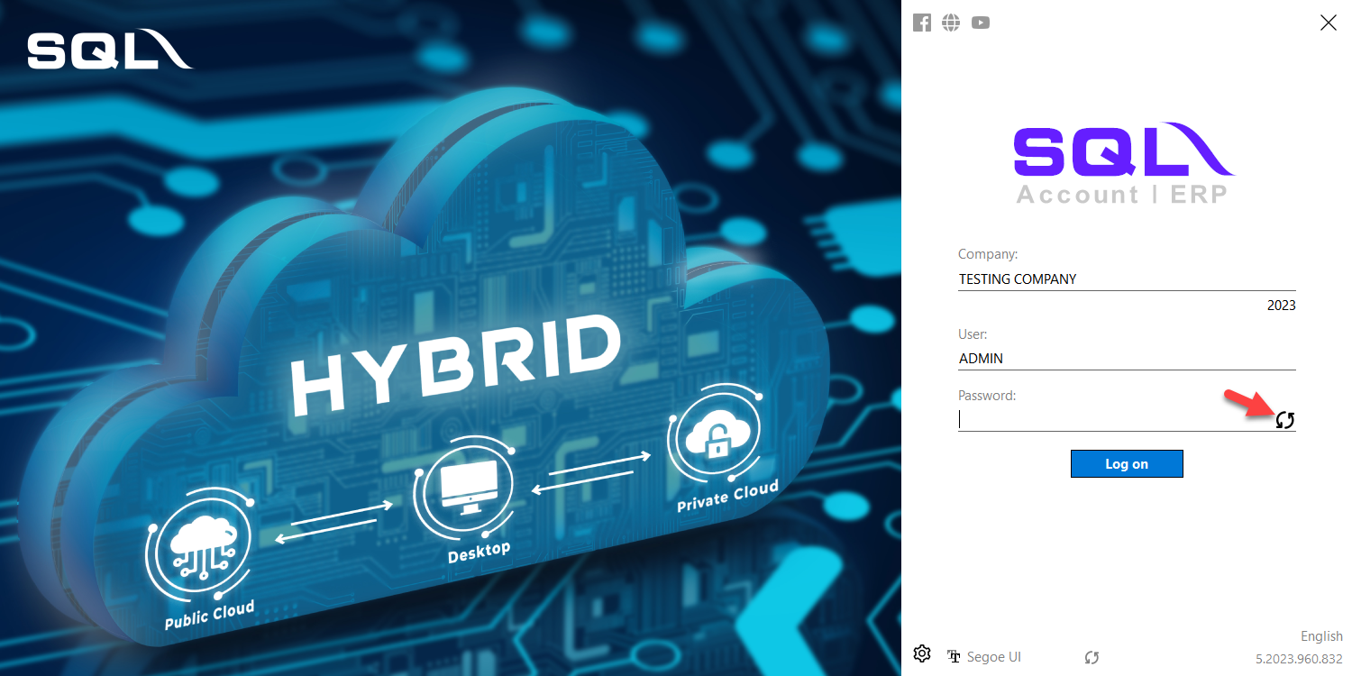

Step 4:
Click “Yes” to reset ADMIN password
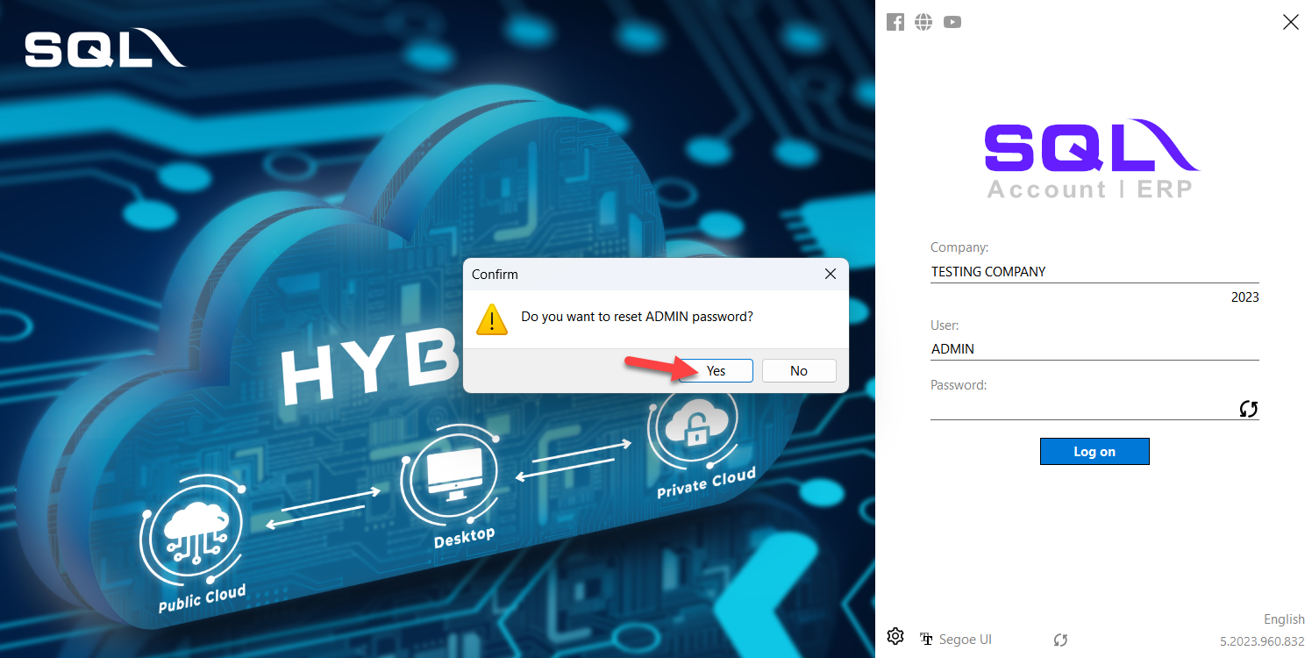

Step 5:
- Read the Challenge Code to SQL ACC Representative and wait for a response code. (Please keep this window open else the challenge code will be reset)
- Key in the Response Code provided by SQL and click OK.
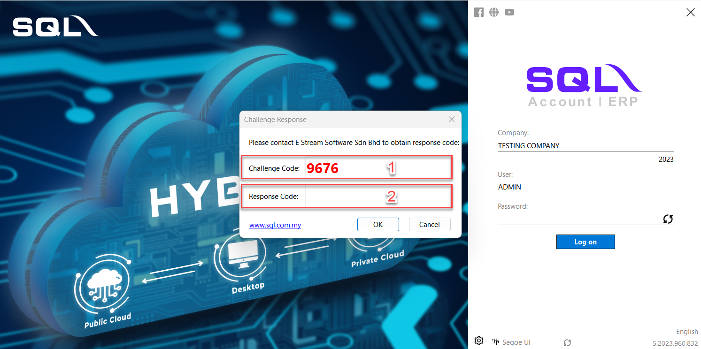

Step 6:
- Enter new ADMIN Password
- Enter Confirm ADMIN password
- Click OK.
